Title (Times New Roman, 13, Bold)
author ^{1,*}, author ²
ABSTRACT
The paper must demonstrate originality, a sound scientific methodology, and up-to-date content in both topic and presentation. The accuracy of language and clarity of style must be observed. The paper must not have been previously published or submitted for publication to any other party. The similarity (quotation) rate must not exceed 20%.
The abstract must be concise, clear, and able to provide an overall idea of the paper. It should clearly state the problem, indicate the purpose of the research, explain the proposed approach, and conclude by highlighting the main results. Citations, references, and non-standard or uncommon abbreviations should be avoided in the abstract. The abstract must not exceed 250 words.
KEYWORDS: The number of keywords should range from 3 to 6.

Submitted on x; Revised on x; Accepted on January x24
© 2026 Al-Wataniya Private University, all rights reserved.
1 Faculty, University, City, Country.
2 Faculty, University, City, Country.
* Corresponding author. E-mail address: x@wpu.edu.sy

1. Introduction
The research paper should essentially include the following sections, or their equivalents: 1) Introduction; 2) Related Work; 3) Research Materials and Methods; 4) Results and Discussion; 5) Conclusions and Recommendations; 6) References.
The main text should be formatted as a single-page layout on B5 paper. The margins (left, top, right, and bottom) should be 2.5 cm. The manuscript must be prepared using Microsoft Word, with single line spacing. The body text font should be Times New Roman, size 11 pt.
All ideas based on information or findings from previous studies must be properly referenced [1]. Citations in the text should be placed immediately at the end of the stated information or idea [2]. Reference numbering in the text must be consistent and sequential, matching the order of the reference list [3].

2. Headings Formatting
Headings should be formatted as follows:
- Main section heading: Times New Roman, bold, 13 pt.
- First subheading: Times New Roman, bold, 12 pt.
- Second subheading: Times New Roman, bold, 11 pt.
- Third subheading: Times New Roman, italic, 11 pt.
Note: All the above headings should be formatted with the following spacing: 10 pt before and 0 pt after.

3. Table, Figure, and Equation Formatting

3.1. Table Formatting and Captions
The table content should be formatted as follows: Times New Roman, centered, regular, 10 pt. The table caption should be formatted as: Times New Roman, centered, italic, bold, 9 pt, and it should be placed above the table. The spacing for the table caption should be 6 pt before and 0 pt after. The spacing for the text following the table should be 6 pt before and 0 pt after.
Table 1: Difference Between Article and Survey
Survey | Article | Item
Identifying current gaps to guide future research | Solving a research problem in a scientific field | Purpose
Providing a comprehensive foundation on the methods used | A new research idea | Content type
A systematic research methodology for collecting, studying, and analyzing information | Scientific originality and novelty of the topic | Characteristics

3.2. Figure Formatting and Captions
The figure must be clear, and its content should be easy to read. The spacing for the figure should be 6 pt before and 0 pt after. The figure caption should be formatted as follows:
- Arabic captions: Simplified Arabic, centered, italic, bold, 10 pt.
- English captions: Times New Roman, centered, italic, bold, 9 pt.
The caption should be placed below the figure, with spacing set to 0 pt before and 6 pt after. Example:
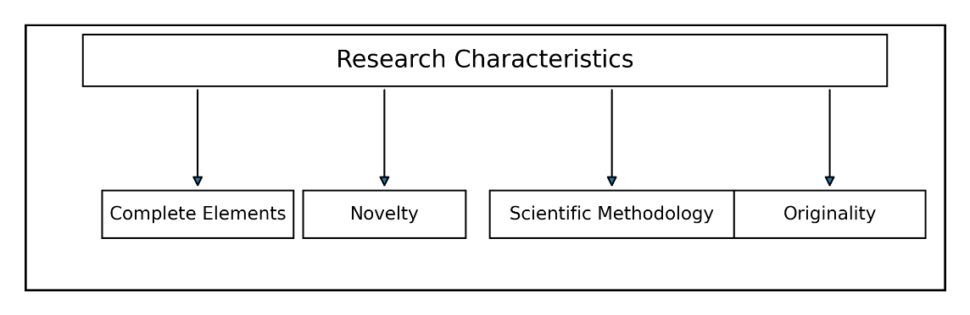

Figure (1): Research Characteristics

3.3. Equation
All equations mentioned in the main text should be written using the following format: Cambria Math, centered, italic, bold, 10 pt. The equation spacing should be 6 pt before and 6 pt after, as shown in Equation (1):
$A=πr^{2}$ (1)

References
- All references must be written in English, whether they are journal articles, conference papers, or books.
- Each reference should be typed in Times New Roman, 11 pt, with spacing set to 0 pt before and 0 pt after. In addition, the first line should have a special indent of 0.5 cm.
- If a reference is in Arabic or any other language, it must be translated into English.
- References must be formatted according to the IEEE style. The following are the reference-formatting cases:
- Research Article in Journal:
[1] A. A. Author, B. B. Author, and C. C. Author, “Title of the article,” Journal Name, vol. x, no. y, pp. xxx–xxx, year, doi: xx.xxxx/xxxxx.
- Research Paper in Conference:
[2] A. A. Author and B. B. Author, “Title of paper,” in Proc. Conference Name, City, Country, Year, pp. xxx–xxx, doi: xx.xxxx/xxxxx.
- Book:
[3] A. A. Author, Title of Book, xth ed. City, Country: Publisher, Year.

